Project Readme file:

Question 1:

Input and Output

It is console application ,you need to provide in this way.

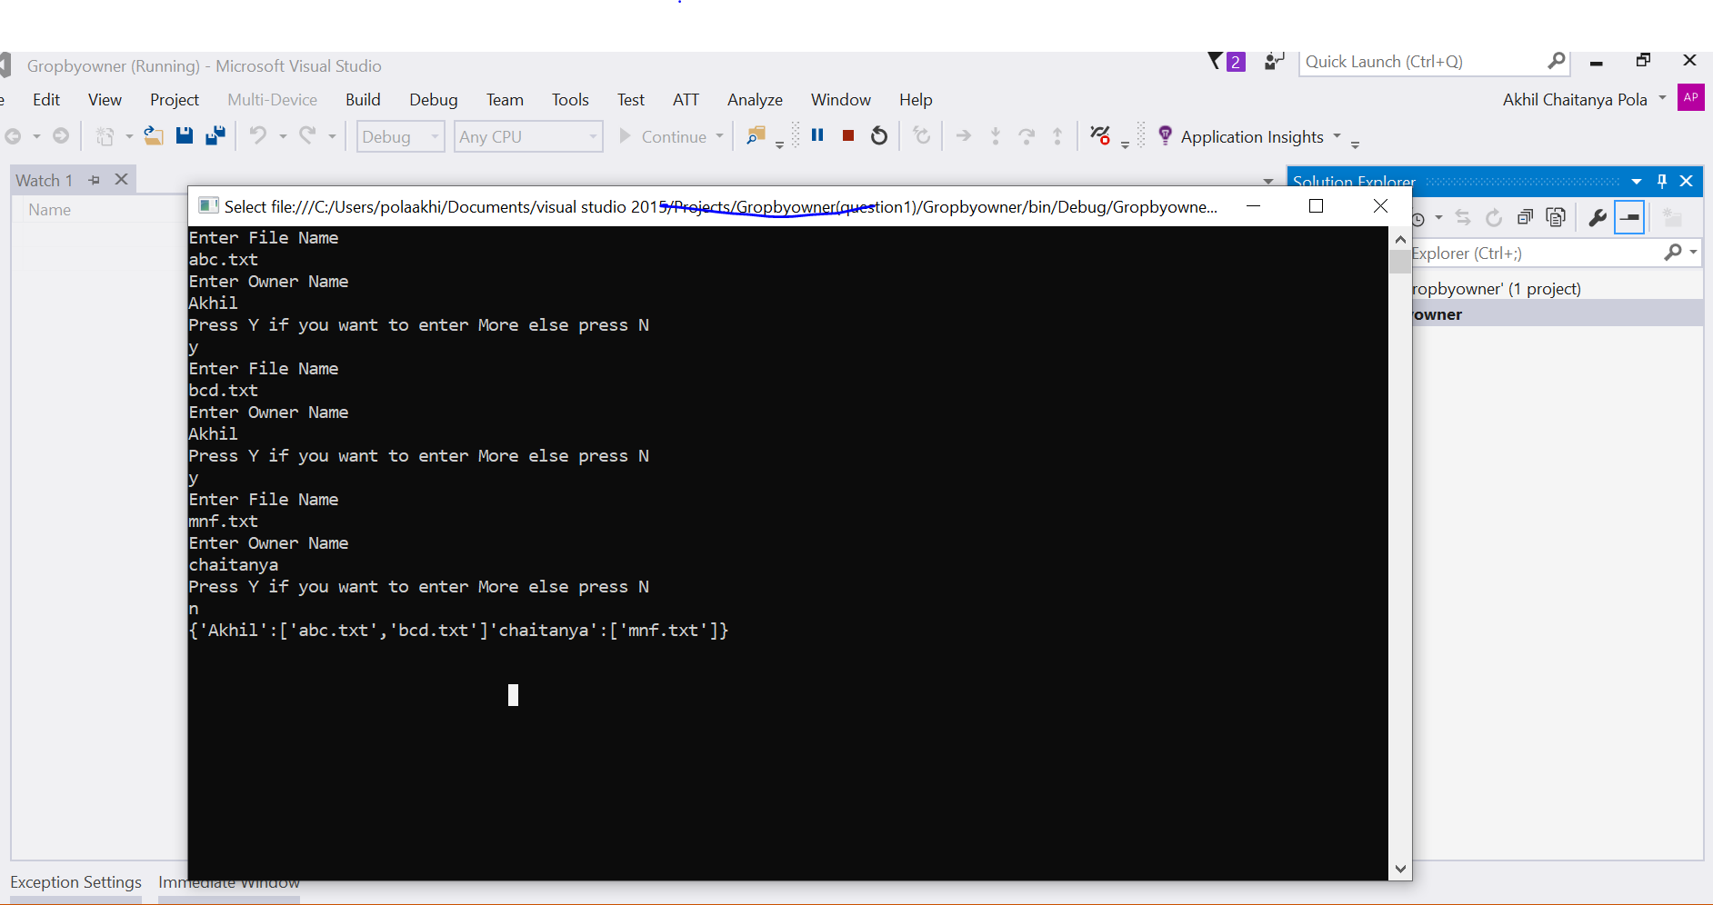

Question 2:

It is also a console application ,input Is picked fromapp.config file ,so to test the appliacion please change output in appconfig file

input

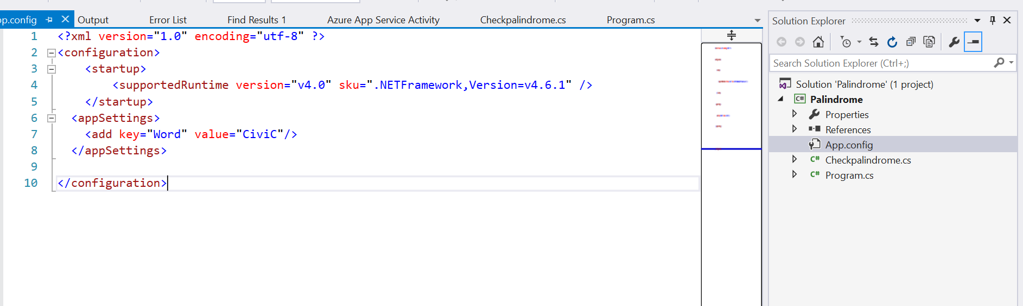

Output

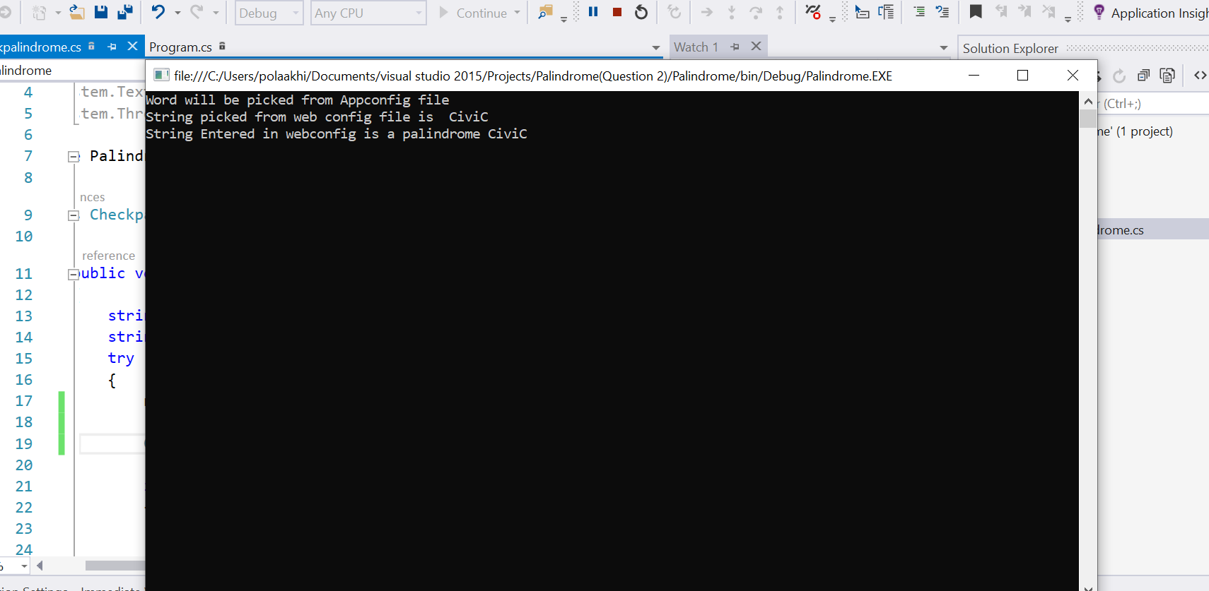

Question 4:

It is also a console application ,inputs will be fetched from app.config file ,so to test the application inputs to be changed in app.config file.

Input:

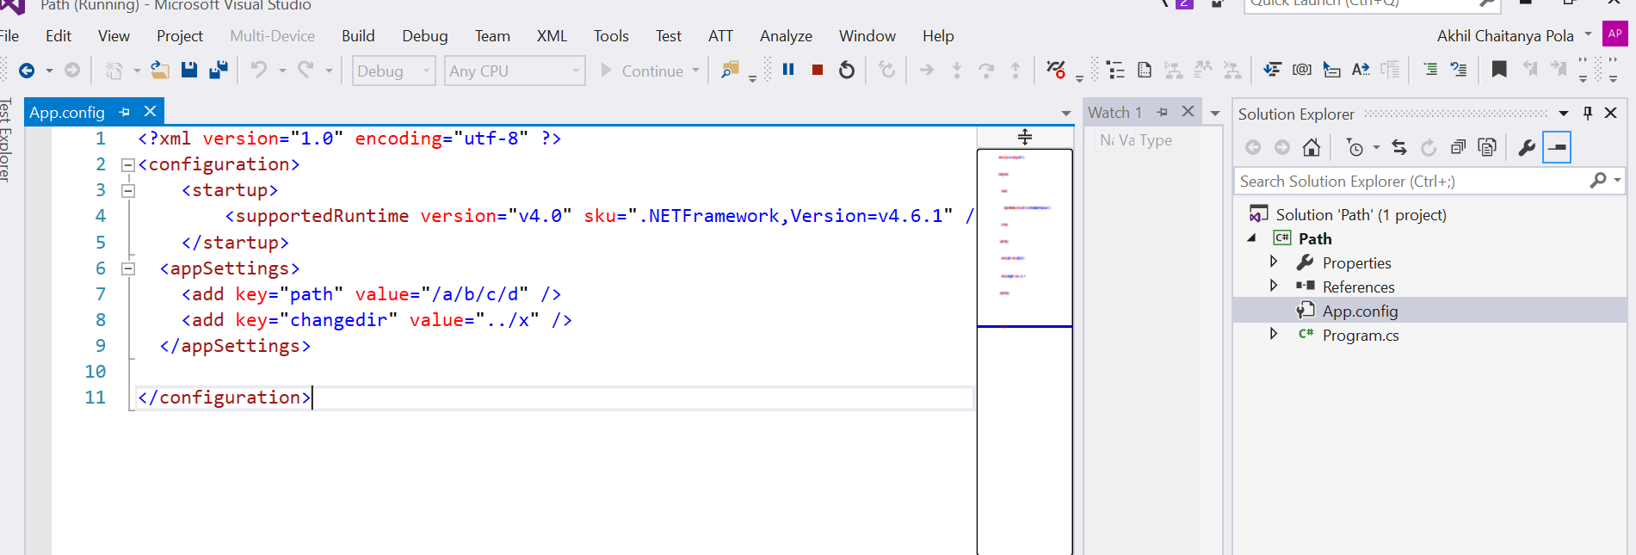

Output

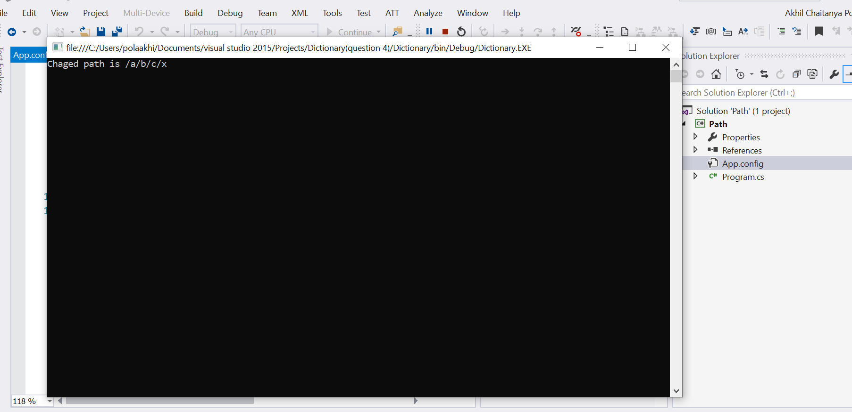

It is also a console application ,inputs will be fetched from app.config file ,so to test the application inputs to be changed in app.config file.

Question 3:

Input

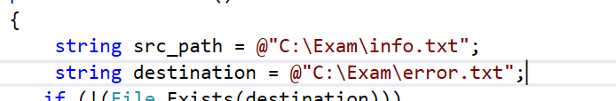

Create a input fie in C:\Exam\info.txt and add text lines in that file ,if lines contains info or warning(case insensitive),those lines are addedto destination path.

Question 5:

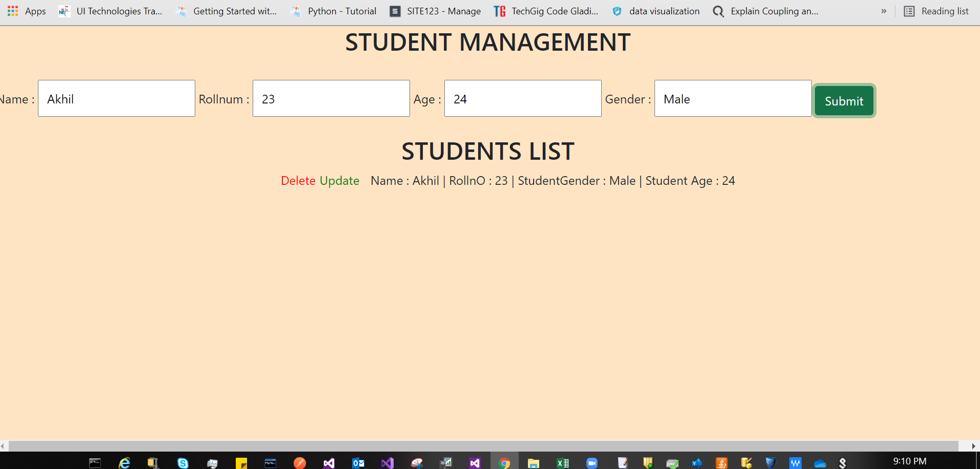

Just double click on html file and add the data ,you can the data below and if you click on delte record will be deleted and click on update will ask for update the details